C6_4

setwd(".")   
library(knitr)

#Apartado A

PA <- 1-pchisq(24*9.1/6,24)  
PA

## [1] 0.0501701

#Apartado B

PBmenos<-pchisq(24*10.745/6,24)  
PBmas<-pchisq(24*3.462/6,24)  
PB <- PBmenos-PBmas  
PB

## [1] 0.9400097

#Visualizacion

x <- seq(0,1,0.01)  
plot(x, pchisq(x*(9.1/6),24), col="blue", type="l",  
 xlab="Probabilidad", ylab="", lwd=2)  
abline(v=pchisq(24*9.1/6,24), col="green", lwd=2)  
abline(v=pchisq(24*10.745/6,24), col="darkred", lwd=2)  
abline(v=pchisq(24*3.462/6,24), col="red", lwd=2)  
grid()

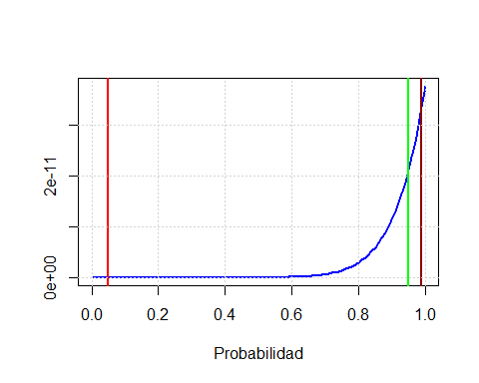

Conclusiones